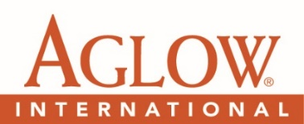

2022 CONFERENCE VOLUNTEER FORM
Clip and Send to (contact information below)
(No later than October 15, 2022)

First Name Last Name

Address City

State Zip Email Phone

Arrival Date AM / PM Time Zone Departure Date AM / PM

I am fluent in: English Spanish Other (Please specify language)
Preferred Committees to serve on (List two)

Volunteers are encouraged to return completed General Conference Volunteer Forms by mail to:
Arvie Murff – P.O. Box 1749, Edmonds, WA 98020 or email: ArvieMurff@aglow.org

2022 CONFERENCE VOLUNTEER FORM
Clip and Send to (contact information below)
(No later than October 15, 2022)

First Name Last Name

Address City

State Zip Email Phone

Arrival Date AM / PM Time Zone Departure Date AM / PM

I am fluent in: English Spanish Other (Please specify language)
Preferred Committees to serve on (List two)

Volunteers are encouraged to return completed General Conference Volunteer Forms by mail to:
Arvie Murff – P.O. Box 1749, Edmonds, WA 98020 or email: ArvieMurff@aglow.org

