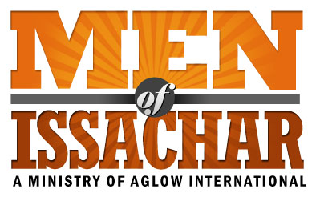
MOI LEADERSHIP QUESTIONNAIRE
(U.S.)
This form is for computer use; or, you can print and fill in by hand.

 | Name: |  |  |  |  |  |  |  | Date:
 | Address:
 | City: |  |  |  | State: |  |  |  | Zip Code:
 | Phone: |  | Home: |  | Cell:
 | E-mail: |  |  |  |  |  |  |  | New MOI Group
 | Date of birth: |  |  |  |  |  |  |  | Existing MOI Group
Leader |  |  |  | Co-Leader |  |  | (Name of Group)
I agree to these statements:
I have accepted Jesus Christ as my personal Lord and Savior.
I agree with the Aglow International vision and mission statements: I agree with Aglow’s belief statement of “what we believe…” on the website.
I attend church regularly.
If I have ever taken part in any occult activities, I have renounced such teachings and activities and have asked God to forgive me.
I live a moral and upright life according to Biblical Standards found in Galatians 5:16-26
I agree to become a Global Partner of Aglow in my nation or through Aglow International.*

*If you wish to sign up for Global Partnership using a credit or debit card, please go to this link on our web site: http://www.aglow.org/give/global-partnership or phone Aglow headquarters at 425-775-7282.

Are you baptized in the Holy Spirit with evidence of speaking in tongues? |  | Yes | No
When?
Church attending? |  |  | For how long? |  | Denomination:
Do you have someone who regularly encourages, mentors, and/or admonishes you (Romans 15:14)? |  |  |  |  |  |  | Yes No
What is your relationship to that person?

MOI Aglow International Director Approval:

Date:
Dave McDaniel

Mail complete form to: or Scan and email to davemcdaniel@aglow.org

Aglow International
Attn.: Dave McDaniel, MOI Director
P O Box 1749
Edmonds WA 98020

