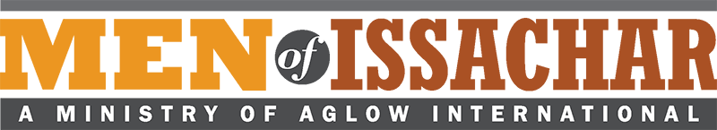
MOI Leadership Questionnaire
(International)
This form is for computer use; or, you can print and fill in by hand.

Name: |  | Date:
Address:
City: | Nation: | Post Code:
Home Phone: | Cell:
E-mail: |  | New MOI Group
Date of birth: |  | Existing MOI Group
Leader Co-Leader
(Name of Group)
I agree to these statements:
I have accepted Jesus Christ as my personal Lord and Savior.
I agree with the Aglow International vision and mission statements: I agree with Aglow’s belief statement of “what we believe…” on the website.
I attend church regularly.
If I have ever taken part in any occult activities, I have renounced such teachings and activities and have asked God to forgive me.
I live a moral and upright life according to Biblical Standards found in Galatians 5:16-26.
I agree to become a Global Partner of Aglow in my nation or through Aglow International.*

Are you baptized in the Holy Spirit with evidence of speaking in tongues? Yes No
When?
Church attending? For how long? Denomination
Do you have someone who regularly encourages, mentors, and/or admonishes you (Romans 15:14)? Yes No
What is your relationship to that person?

*If you wish to sign up for Global Partnership using a credit or debit card, please go to this link on our web site: http://www.aglow.org/give/global-partnership or phone Aglow headquarters at 425-775-7282.

Please submit this form to your Aglow National Leader
and to
MOI Aglow International Director, Dave McDaniel

Aglow National Leader Approval:
Date:

MOI Aglow International Director Approval:
Date:
Dave McDaniel

Mail complete form to: or Scan and email to davemcdaniel@aglow.org

Aglow International
Attn.: Dave McDaniel, MOI Director
P O Box 1749
Edmonds, WA 98020

